Tulips Project: Suitable hardware

The tulips monitoring system performs monitoring operations. This stage involves identifying devices that can effectively sense environmental conditions, process data, display real-time information, and control external actuators. Each component has been chosen based on its compatibility with the microcontroller as well as its functionality

Table of content
ESP32 DevKit V1 microcontroller 2
DHT22 temperature and humidity sensor 3
MQ-5 Gas sensor 3
1.3-inch 12C OLED display 4
5V relay module 4

Select suitable hardware as follows:
- ESP32 DevKit V1 microcontroller
- DHT22 temperature and humidity sensor
- MQ-5 Gas sensor
- A 1.3-inch I2C OLED display
- 5V relay module

ESP32 DevKit V1 microcontroller

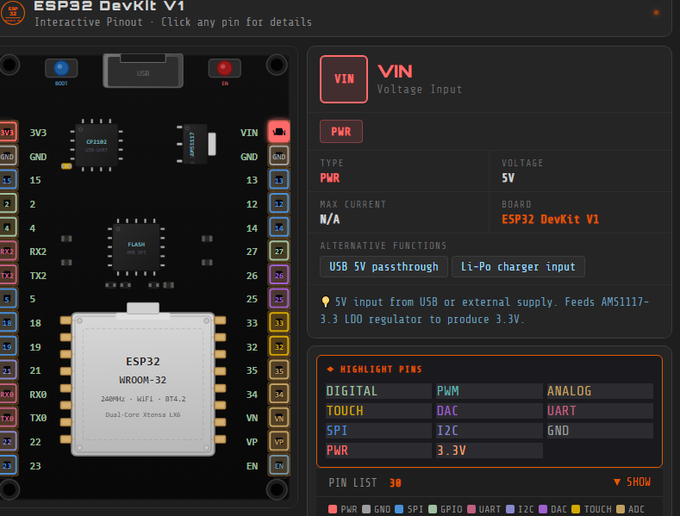
Figure 1: Esp32 DevKit v1 microvontroller
The ESP32-DevKit v1 is a widely recognized development board built around Espressif's ESP32-WROOM-32 ESP32 module. This powerful chip integrates Wi-Fi and Bluetooth connectivity, making it an ideal choice for a vast array of Internet of Things (IoT) Applications (Espressif Systems, 2020). It is also selected due to its ability to handle multiple sensor inputs

DHT22 temperature and humidity sensor
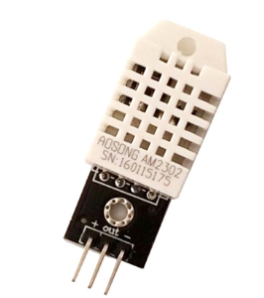
Figure 2: DHT22 temperature and humidity sensor
The DHT22 AM2302 was selected for measuring environmental temperature and humidity. It is a low-cost digital sensor that uses a capacitive humidity sensing element and a thermistor to measure surrounding air conditions (Aosong Electronics, 2018)

MQ-5 Gas sensor
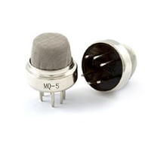
Figure 3: MQ-5 Gas sensor
The MQ-5 gas sensor uses 5nO² semiconductor material whose conductivity changes in the presence of flammable gases (Winsen Electronics, 2018).

1.3-inch 12C OLED display
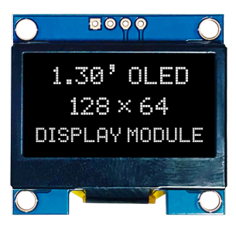
Figure 4: 1.3-inch 12C OLED display
A 1.3-inch OLED display I2C is a compact visual output interface that displays real-time readings. It offers a resolution of 128×64 pixels and communicates via the I2C protocol, making it efficient for embedded systems with limited GPIO pins (Solomon Systech, 2017). It was selected due to its low power consumption and high readability.

5V relay module
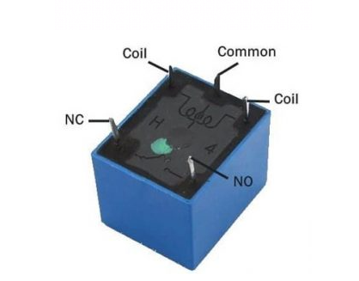
Figure 5: 5V relay module
The 5V relay is an automatic switch commonly used in automatic control circuits to control high current with a low-current signal. It allows the ESP32 to safely control devices such as fans, pumps, or alarms without direct exposure to high current circuits (Songle Relay Datasheet, 2019).

References
Espressif Systems. (2020). ESP32-WROOM-32 Datasheet
Aosong Electronics. (2018). DHT22/AM2302 Datasheet
Zhengzhou Winsen Electronics Technology Co., Ltd. (2018). MQ-5 Gas Sensor Datasheet
Solomon Systech. (2017). SSD1306/SH1106 OLED Datasheet
Songle Relay. (2019). SRD-05VDC Relay Module Datasheet

